Notes for MISM Exam:

Question 1: Entity Information Category

Entity information category is the circles within a system diagrams and represents the departments within a certain system in a business or any type of process.

c) Student Information

Question 2: Leveraging Computer Hardware to improve business process

Technology can be leveraged to improve work systems and when it leverages technology it has to deploy it strategically.

b) The deployment of a network connects all departments

Question 3: Competitive advantage of a company and its connection towards leveraging of resources.

Sustainability of the products would be due to the Pre-Production subsystem that accounts on the

b) Pre-production subsystem (Wrong) its d)Production Subsystem

Question 4: Improve effectiveness of an organization.

d) The CEO made a decision to sell a business unit for which the company lacked competencies.

Question 5:

1200 dpi (Dots per inch)

A **PPM** rating on a **printer** gives you the speed at which a particular **printer** can print a page of text in black ink.

a)Laser printer

Question 6: What type of media makes a disc have a much higher density, replay quality, content retention and duplication quality.

Optical disc is likely to replace hard drives in data centers and on cloud servers, because they’re able to use 1000 times less power, hold up 10TB and life span of 600 years.

Optical Media makes it possible to create information on a disc at higher density higher replay quality better content retention and duplication quality and have more resistance towards magnetic energy.

C) Optical media

Question 7: Large computer monitor what part of hardware:

**Output hardware** category includes devices that enable computers to interact with users by transforming computer bits into human forms of interactions, such as speech, texts, sound, drawings, and pictures

d)Output hardware

Question 8: Hard drive memory system:

Magnetic storage device examples include magnetic tape backup storages (used by some mainframe computers) and the hard drives that are located in most computers.

b)Magnetic energy

Question 9: Component that stores information while computer is on:

The primary storage is the main storage component that holds small quantities of instructions, data and software programs *temporarily* (volatile), as electrical bits, for the CPU while the computer is turned on. The most common type is called a random access memory (RAM). Variations are SRAM, DRAM etc

d)Random access memory

Question 10: Video editing software slows down the speed of the computer:

The **primary storage** is the main storage component that holds small quantities of instructions, data and software programs temporarily (volatile), as electrical bits, for the central processing unit (CPU) while the computer is turned on.

c)The size of the random access memory is smaller that what the new software requires.

Question 11: Success of Zara

Zara used specific technologies (such as, software, hardware, network) were used to inform, enable, coordinate, collaborate or control specific business processes to enable Zara to achieve quick responses in the following departments: Design; Manufacturing and Logistics and Stores.

d) They leverages technology, people, information and unique procedures to create sustainable competitive advantage.

(Wrong) the answer E

Question 12: Good representation of Moore’s Law:

For processors, Moore’s Law means that next generation chips should be twice as fast in about *eighteen* months, but cost the same as today’s models (or from another perspective, in about a year and a half, chips that are same speed as today’s models should be available for half the price).

b)The number of transistors on a CPU chip would double every two years.

Question 13: Outcomes of the impact of Moore’s law except:

d)Computers are able to use larger sizes of primary storage

Question 14: Which computer would a business use to process information for several mid-range servers:

A medium-sized computer system or server. Midrange computers encompass a very broad range and reside in capacity between high-end PC servers and mainframes. For example, IBM's Power Systems are its midrange line for both business and scientific applications.

e)Desktop computer

Question 15: Hardware that is used by ipads:

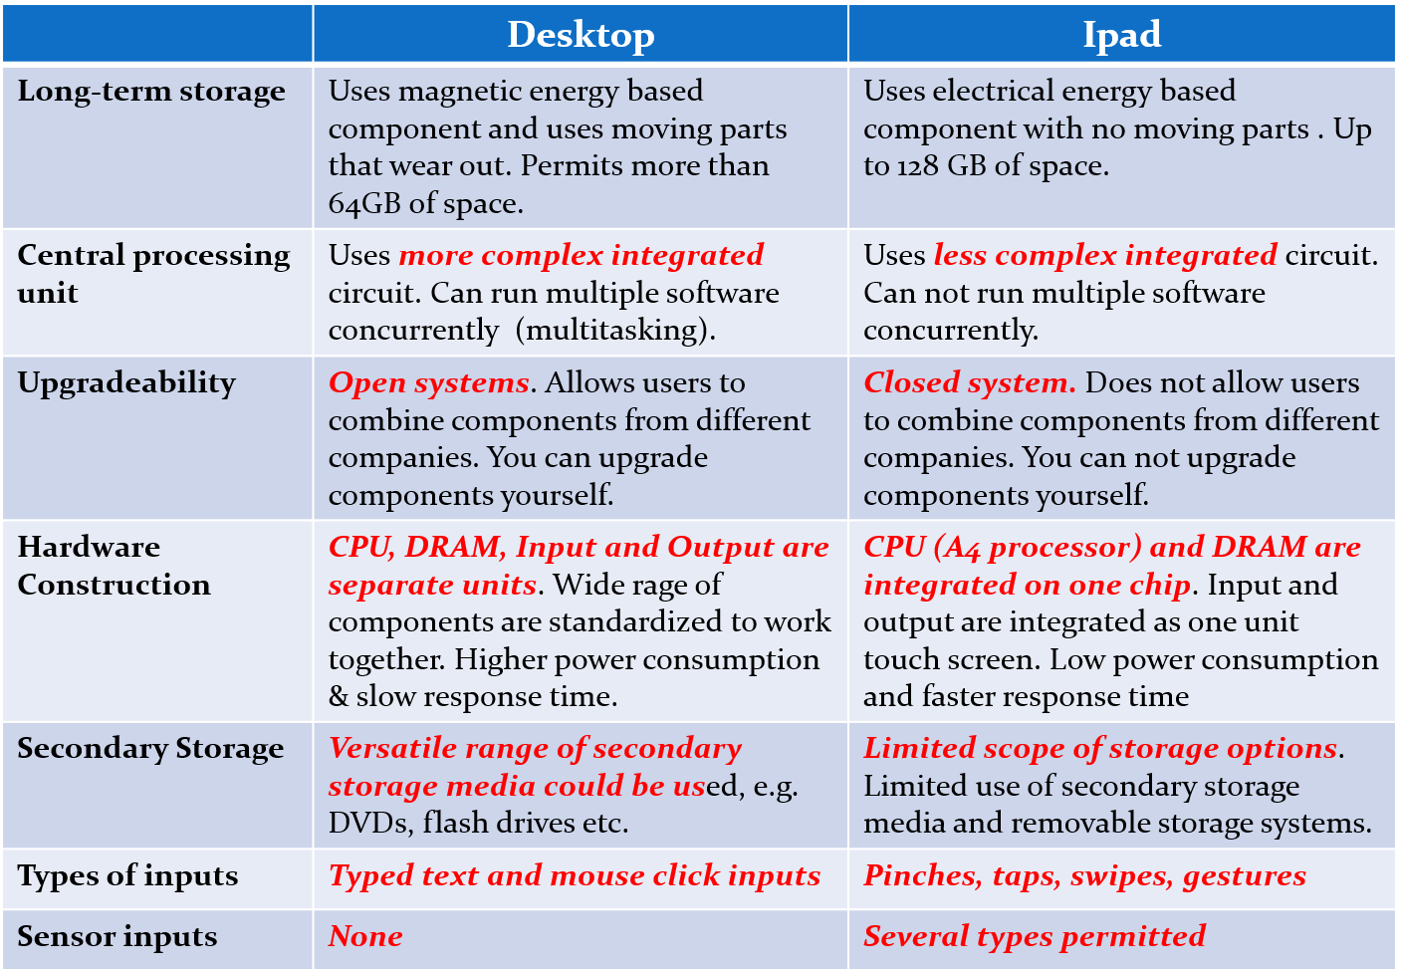

b) The processor and the primary storage are integrated on the same chip.

Question 16: Deploy new software for improving the production of news and content:

Focus on finding the software that fits best towards the company’s main interest.

c) News and content management software

Question 17: Control most of the hardware of a mainframe computer

**Middleware** software is the kind of software that facilitates the exchange of data between two application programs within the same environment, or between software that are located on different hardware and network environments. The three most common types of middleware are: (1) communication (2) database and (3) system middleware.

**Operating systems software** is a group of interdependent computer programs that provide the rules, functions, and controls needed to control computer hardware and the processing that hardware components perform.

An **application (or functional) software** is a group of independent programs that contain the rules, functions, sequence and data requirements that are needed to solve discipline-specific tasks (functional tasks), such as problems in finance, marketing, accounting, engineering, accounting, production, facilities management, health-care and so on.

A functional software contains the business steps and processes of a functional area in digital format. For example, the codified inherent process in a finance software would stipulate the data inputs are needed for a task, define the equations that are needed to compute a result, define the sequence in which the equations are to be calculated, define the results which are to be stored separately, define the results that have to be shown to the user, and define the data inputs that are required to begin to execute the task

**Utility software** is the name given to the category of software that extends the capability of the operating system.

c) Mainframe operating systems software

Question 18: Tech used for communication between ATMs and the database

An ATM is simply a **data terminal** with two input and four output devices. Like any other data terminal, the ATM has to connect to, and communicate through, a **host processor**. The host processor is analogous to an [Internet service provider](https://money.howstuffworks.com/personal-finance/banking/internet-infrastructure1.htm) (ISP).

e)All of the above

Question 19: Account receivables, account payables, new accounts creation, credit and debit balance management.

e)Accounting software

Question 20: Create a small program that would enable people to send money to each other via smart phones.

e)Applications software

Question 21: Information lifecycle management approach:

ILM is the approach of managing information management costs of an organization in accordance with the business requirements, legal requirements and business value of information. Information has a life-span. It is also called the Information Lifecyle. It has five distinct Phases, these are Creation/Capture, Storage, Distribution/Usage, Maintenance, and Disposition. To properly manage information in an organization, those responsible must take a lifecycle management approach. It also means that one must keep information as long as it is required by law. It also means that one should place information in the most appropriate storage location. Information that is not needed regularly should probably not be stored with information that has to be routinely accessed.

d)Retain all its transactional data in remote backup storage sites

Question 22: New server hardware that would be shared by all the workers concurrently

Operating systems (OS) software - A group of interdependent computer programs that provide the rules, functions, and controls needed to control computer hardware and the processing that computer hardware perform

**Single-user, single task** - As the name implies, this operating system is designed to manage the computer so that one user can effectively do one thing at a time. The Palm OS for Palm handheld computers is a good example of a modern single-user, single-task operating system.

**Multi-user** - A multi-user operating system allows many different users to take advantage of the computer's resources simultaneously. The operating system must make sure that the requirements of the various users are balanced, and that each of the programs they are using has sufficient and separate resources so that a problem with one user doesn't affect the entire community of users. Unix, VMS and mainframe operating systems, such as *MVS*, are examples of multi-user operating systems

Enterprise software: Software product can only be used by multiple groups of people (e.g. assigned to multiple functional areas[> 20 people]) concurrently at any given time.

b)Multiuser OS

Question 23: Open source software

Open source software: Developed by volunteers. The source code and compiled code are made available to others for use and modifications.

d) The open source software works with any operating system and on any hardware platform.

|  |  |  |
| --- | --- | --- |
|  | **Proprietary  (Closed Source)** | **Open Source  Software** |
| Ownership | Software is owned by a company or individual | Software is not owned by a company but by a community |
| Distribution of code | Only the complied code is distributed to people | Both the complied and source code are distributed to users |
| Copyright | A copyright license limits how users are permitted to use the software code | Open source license broadly permits users to use modify and even re-distribute code software code |
| Purchase cost | Varies from moderately to very expensive | Varies from free to low cost |

Question 24: Kind of data “12 terabytes of data, which includes data from its email software and data from customer comments and online surveys from its web sites”

Unstructured data refers to information that *does not have a specific or uniform model for organizing* its content. It has mostly unstructured text, including dates, numbers, and other characters.   
This kind of information is very hard to maintain in a form that permits easy retrieval of data.

Structured data refers to information that *has a specific rule for organizing* its content.

E.g. The business rule could be ***event (ticketing) number + event location + invoice date***  
This kind of information is very hard to maintain in a form that permits easy retrieval of data.

b)Unstructured data

Question 25: Tasks that are executed by an operating system:

They are used to perform general control tasks related to activities of hardware.

* + Select the printer to use for printing.
  + Determine which secondary storage is used to save files
  + Determine how many people can work concurrently on a RAM
  + Changing the language that will be used on a computer.
  + Organize how data will be stored on the hard drive.
  + Determine how to change the resolution of your monitor
  + Determine if erased files can be undeleted
  + Determine how to create folders on a computer
  + Determine how commands are activated by users (graphical versus non-graphical user interfaces).

b)Create an account for a new business customer

Question 26: New version of the software that would be used on the Internet

* 1. **Wide area networks** (**WANs**)–connects computers at different geographic sites. The Internet is the most widely used WAN.
  2. The **Internet is a network of networks**. One can view it as a connection of hundreds of thousands of WANs. It is a global WAN that is not owned/used by any one company

In order to be able expand LAN, wireless access point is used to expand it.

b) Built for wide area network distribution.

Question 27: Six functional software that are used in the departments of the retail store do not use a database to store information

Problems With the Traditional Approach for Storing Data:

* Data redundancy
* Program-data dependence
* Data integrity challenges
* Storage costs
* Data accuracy issues
* Lack of data integration

Advantages of the Database Approach for storing Data:

* Little or no data redundancy
* Program-data independence
* Higher data integrity
* Lower storage costs
* Better data accuracy
* Efficient data integration
* Efficient data update processes

e)All of the above would be issues

Question 28: Database table that uniquely identifies each record.

c)Primary key

Each table will have a primary key columns.

Primary key is the column that enables one to uniquely identify each record in a table. The data in each field of primary key must be unique for each record. (You cannot use lastnames or numbers that can be reassigned, such as social security numbers)

Question 29: Create quarterly and annual plans based on goals of the company and involve comparison of results to plans and the identification of variances between plans and results. The role is associated with which level of the organization:

Transactional activities (**Execution and decisions**)

* + Locating/finding past records on systems so as to understand what has happened
  + Creating a new action or record based on a new request
  + Changing past record or updating a past record based on new events that has happened
  + Documenting the closing or completion of a business activity
  + Requesting authorization and access to resources needed to complete the next step of a business activity

Tactical activities (**Control**)

* + Compare current business results with the level of performance that was achieved in prior periods
  + Compare current business results with the level of performance planned
  + Compare ending business results with the resources at end of period

Tactical activities (**Planning**)

* + Estimate the type and kind of resources that are needed to accomplish specific outcomes in a period
  + Allocate different resources to departments that have to be achieved in a period
  + Assign responsibilities for outcomes to specific departments and results
  + Schedule the mode in which activities have to be accomplished in the period

Tactical activities (**Learning, diagnosis, prescription**)

* + Understanding a situation or problem more thoroughly
  + Understanding the weaknesses and strengths of solution options more thoroughly
  + Understanding the causes of a problem more thoroughly

Strategic activities (**Long-term Planning and decisions**)

* + Estimate the type and kind of new resources that are needed to accomplish specific outcomes in the next 3 to 4 years
  + Determine the changes in size and new skills to be acquired in a company in the next 3 years
  + Quantify the opportunities for acquisition for the whole company in the next 4 years
  + Decide which companies to buy in the next 4years.

a)Tactical level

Question 30: Types of databases

* Hierarchical Database
* Relational Database
* Object-base Databse
* No Database (Data files/records)

e) Internet databases

Question 31: New finance management software

Difference between Group shared and shared cross:

Functional software with group shared database is usually for people in the same department and are working at the same time. While, a functional software with cross-group shared database, allows people from different departments to work together.

b) Multi-user finance software with group shared functional database.

Question 32: Examples of proprietary software:

Unlicensed proprietary software:

* Developed by private owner and used by private owner.
* Licensed proprietary software: Developed by private owner but compiled code is sold and licensed to others for use only.
* Open source software: Developed by volunteers. The source code and compiled code are made available to others for use and modifications.
* Unlicensed Proprietary software: Software that was developed by a single company, who also developed the hardware by themselves, E.g. Mac Operating system for Mac books.
* Licensed Proprietary software: Software that was developed by a single company but licensed to other hardware makers to use for their products. E.g. Windows Operating system for ATMs.

List of companies and DBMS products they license:

* + DB2 from IBM or Oracle from Oracle Corp.
  + Access and SQL Server from Microsoft
  + MySQL, an open-source DBMS product that is free for most applications

(DOESN’T MAKE SENSE)

Question 33 and 34: Structured query language

No answer

Question 35: Example of Metadata for a database table:

Metadata - Data about the Data

* Databases are self-describing because they contain not only data, but also data about the data (Metadata) in the database
* The format of metadata depends on the software product that is processing the database.
* Because of metadata, no one needs to guess, remember, or even record what is in the database.
* Metadata make databases easier to use (for both authorized and unauthorized purposes).
* Its data about the data for example the amount of transaction.

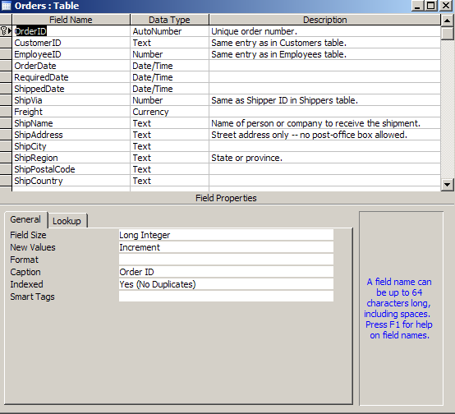

Question 36: Deploying a network in an organization

Computer Network importance to business:

* Sharing valuable resources and assets
* Lowering IS operating costs
* Overcoming barriers of time, place and of organizational boundaries
* Enabling new/better ways to operate, control and innovate

d) Increase the costs of IT maintenance and operations

Question 37:

Local area network must have which device:

1. **Computers and servers** that need to communicate
2. **Transmission media/links** to transfer data over distances from one device to another, e.g twisted pair cable, fiber optic cable, coaxial cable
3. **Communication processors**, devices which enable the management of packets and data traffic flowing from between servers and client computers and other devices e.g. switches, routers, modems and NICs
4. **Communication protocols**  software that enable the creation and exchange of data between networks.

b) Network interface card

Question 38: Good representation of the goal of the Information Lifecycle Management approach:

d)To ensure that information management costs is managed according to its value, as well as   
 business and legal requirements.

Question 39: Represent the essence of Metcalfe’s law

The utility of a network equals the square of its number of users.

b)Each new user to a network increases its value quadratically.

Question 40: Share resources that are on three different servers around a university campus

b)Three bus network

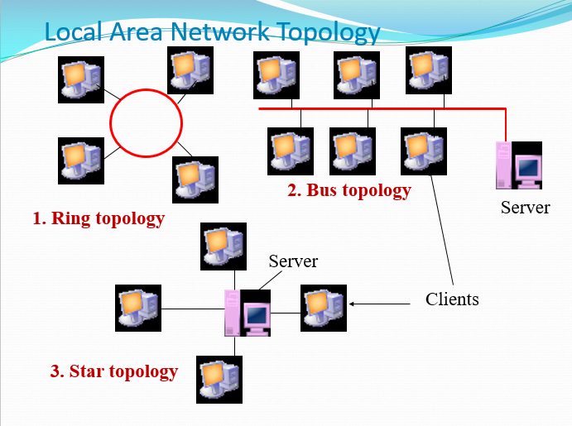

Question 41:Same category of network devices ***except:***

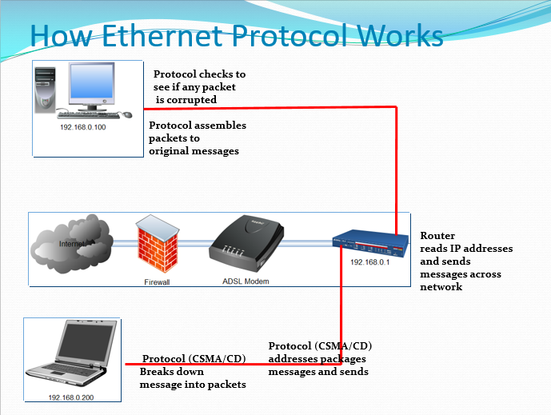

e)Network interface cards

Question 42: Network for hand held scanner and hip computer use:

b)Wide area network

Question 43: Which device can capture and transfer signals from several laptops, using wireless hardware, to a server on a wire-based LAN:

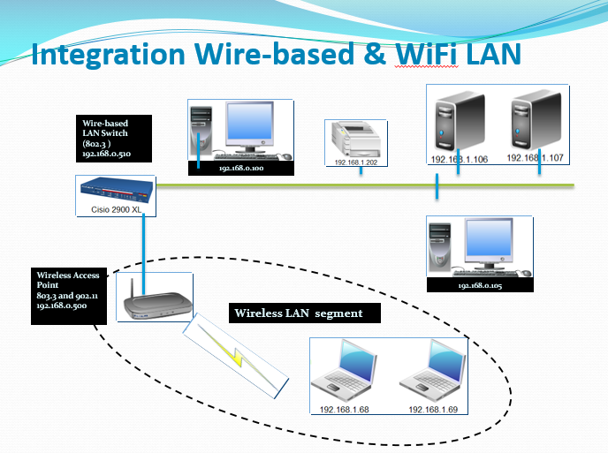

Question 44: The CEO wants all the workers to share the same database-centric functional applications

**Lack of Database-centric Software is a Barrier to Enterprise Information Management**

* Information is stored in different kinds of functional applications
* The functional software store data on hard drives in different kinds of incompatible technical formats
* The functional software and its information is managed by different departments of an organization

Goals of Enterprise Information Management

* Accurate information
* Complete information
* Consistent information
* Relevant information
* Timely information

e)None of the above